Software Design And Analysis Proposal

For

Veterinary Management System

**Prepared By:**

**Maryum Fasih (22i-0756)**

**Abeer Jawad (22i-1041)**

**Faizan Shahid (22i-1235)**



### **1. Introduction**

**1.1 Purpose**This document outlines the software requirements for PAWS, a comprehensive veterinary hospital management system developed for LifeLine Pet Hospital. The system aims to streamline operations such as pet registration, treatment management, billing, and appointment scheduling. PAWS will automate routine administrative tasks and improve the overall quality of animal care by providing an efficient, user-friendly platform for veterinarians, staff, and pet owners.

**1.2 Product Scope**PAWS is a centralized system designed to enhance veterinary hospital operations by automating key processes, reducing manual workloads, and improving patient care. The system will store electronic medical records, handle appointment scheduling, facilitate inventory management, and enable secure billing and payment. Additionally, PAWS integrates features for managing staff roles, appointment reminders, and reporting. This system will be tailored to LifeLine Pet Hospital but will also be adaptable for other veterinary clinics.

**1.3 Title**PAWS: Veterinary Hospital Management System

**1.4 Objectives**

* Develop an integrated system to manage veterinary hospital operations.
* Improve animal patient care by providing efficient data management.
* Enhance administrative efficiency, reducing operational costs.
* Ensure data security and compliance with veterinary regulations.
* Provide real-time updates on patient treatment and billing.

**1.5 Problem Statement**Veterinary hospitals face challenges related to inefficient management of animal care, staff, and resources. Many clinics rely on outdated systems that create bottlenecks in routine tasks such as appointment scheduling, patient record management, and inventory tracking. These inefficiencies lead to delays in treatment, frustrated pet owners, and ultimately lower-quality care. PAWS addresses these issues by automating processes and providing a unified digital platform for seamless communication and efficient operation.

### **2. Overall Description**

**2.1 Product Perspective**PAWS is a standalone solution designed to automate and optimize operations at LifeLine Pet Hospital. The system will replace manual processes and outdated software, providing a more effective solution for managing patient care and clinic resources. PAWS will interact with existing hardware, including medical devices, pharmacy management systems, and payment processing tools.

**2.2 Product Functions**

* **Pet Registration:** Streamline the registration of new pets, saving medical records electronically.
* **Medical Record Management:** Create and update patient records with treatment history, prescription details, and other relevant data.
* **Appointment Scheduling:** Allow pet owners to schedule appointments with veterinarians and receive reminders.
* **Purchasing Medicine:** Select necessary medication and add them to cart to purchase immediately or later
* **Inventory Management:** Track medications, appointments and patient details.

**2.3 List of Use Cases**

* Create Pet Owner
* Manage Pet
* Schedule Appointment
* Manage Account
* Record Prescriptions
* Confirm Appointments
* Decline Appointments
* Buy Medicine
* Get Feedback
* Track Medical History

**2.5 Use Case Diagram**

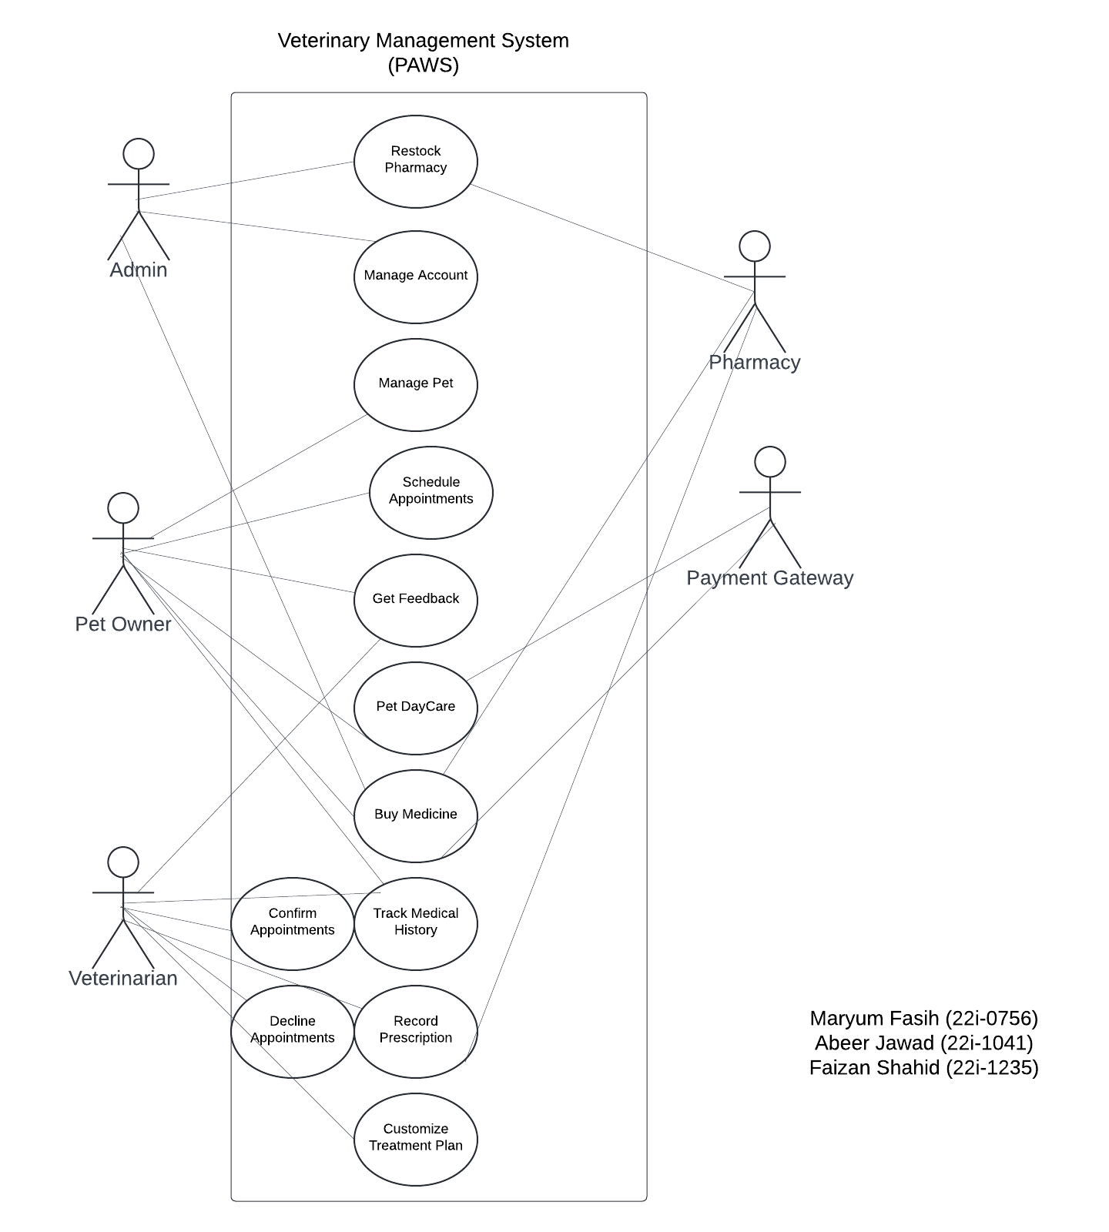

### **3. Other Nonfunctional Requirements**

**3.1 Performance Requirements**

* The system should handle up to 500 concurrent users without performance degradation.
* Data processing should be completed within 3 seconds for patient registration and billing operations.
* Real-time updates should be reflected in the system immediately after an action (e.g., appointment booking, treatment recording).

**3.2 Safety Requirements**

* The system should protect sensitive patient data by implementing encryption and access control measures.
* Backup processes should ensure data recovery in case of hardware failure.

**3.3 Security Requirements**

* User authentication is required for all users (pet owners, veterinarians, staff).
* Access control mechanisms must ensure that only authorized personnel can access and modify patient records.
* The system must comply with relevant data protection regulations (e.g., GDPR, HIPAA).

**3.4 Software Quality Attributes**

* **Reliability:** The system must be available 99.9% of the time.
* **Usability:** The system should be intuitive and easy to navigate for all users.
* **Maintainability:** The system should be easily maintainable with well-documented code and modular design.
* **Scalability:** The system should be capable of supporting future expansions (e.g., additional hospitals or new features).

**3.5 Business Rules**

* Only registered pet owners can schedule appointments for their pets.
* Veterinarians can access and update medical records for pets under their care.
* Inventory updates must be logged by authorized staff.

**3.6 Operating Environment**

* The system will operate on Windows and Linux-based servers.
* It will be accessible via web browsers (Chrome, Firefox, Edge) and mobile devices.
* A cloud-based infrastructure will be used to ensure scalability and reliability.

**3.7 User Interfaces**

**Registration:**

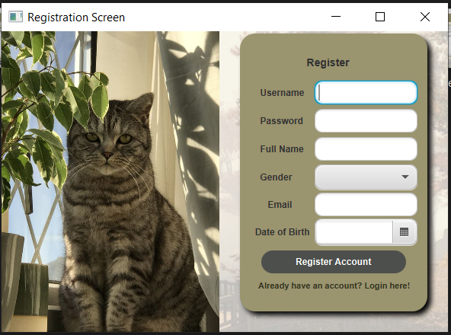

The registration screen allows new users to create an account by entering their personal details like username, password, email, and date of birth etc. It also allows users to head straight to the login page if they’re already logged in.

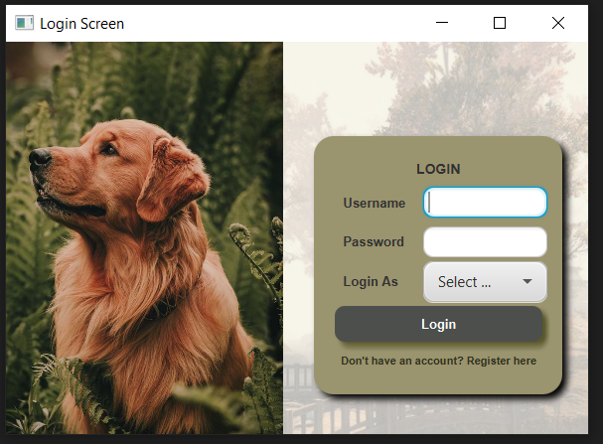

If you're already a registered user, you can log in by entering your credentials and selecting your role (Vet, Pet Owner, or Admin) on the login screen. For new users, a registration link is provided to create an account.

Once you have selected your role you’ll be directed to a customized dashboard and interfaces designed according to your role.

**Vet Interfaces:**

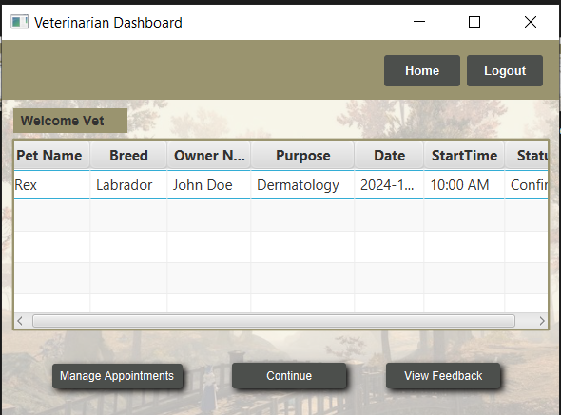

A personalized dashboard that displays all the scheduled appointments that include the owner and their pets details. It also provides quick access to manage appointments, continue workflow, or view client feedback.

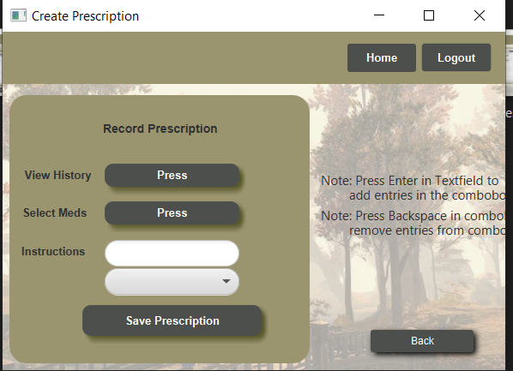

The interface for creating prescriptions for the pet. The View History Button displays

the medical history of the pet during the process of creating a prescription. The Select Meds button is used to add medications in the prescription.

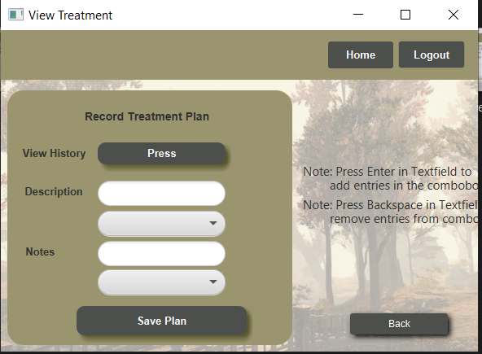

The interface for creating Treatment Plans for the pet. The View History Button displays

the medical history of the pet during the process of creating a TreatmentPlan while the Description and Notes are used to add instructions for following the plan

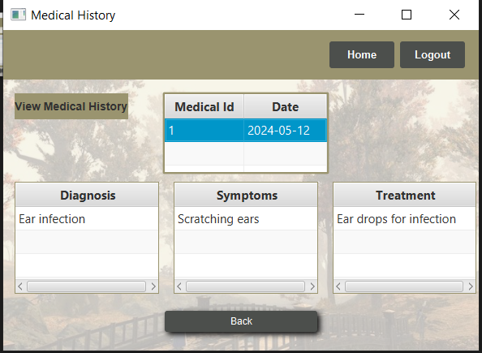

This interface is used to display the medical history of a pet. A medical history contains many records. Meanwhile, A Single record can contain many diagnoses, Symptoms and Treatment Details. This Screen is used to display all of these.

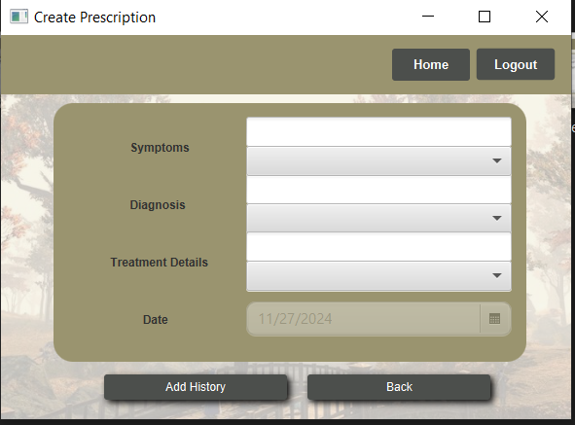

This interface is used to add a new record of medical history for a pet. A record can contain many symptoms, Diagnosis and Treatment Details. The Date of a new Record is always set to the current date so that no medical corruption can occur.

**Pet Owner Interfaces:**

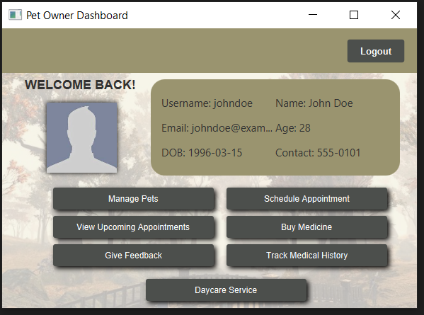

A personalized dashboard displaying the owner's details and quick access buttons for managing pets, appointments, buying medicine, tracking medical history, and daycare services. It also includes an option to give feedback for their vet.

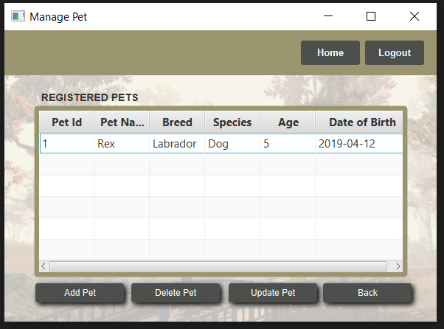This interface is used to manage Pets. It provides a table which allows the Pet Owner to see all of his pets registered with the system. The Pet Owner can also add new pets,remove pet and Update information of already registered pets.

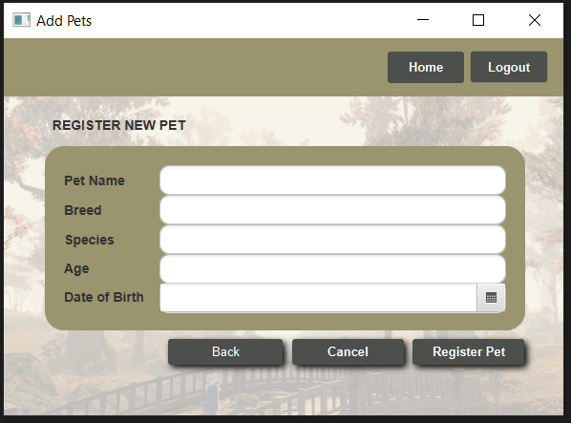This interface is used to Add new Pets. The Pet Owner provides the name,breed, species and date of birth of the pet so that it can be registered with the system. This registration will allow the Pet Owner to book appointments for his pets.

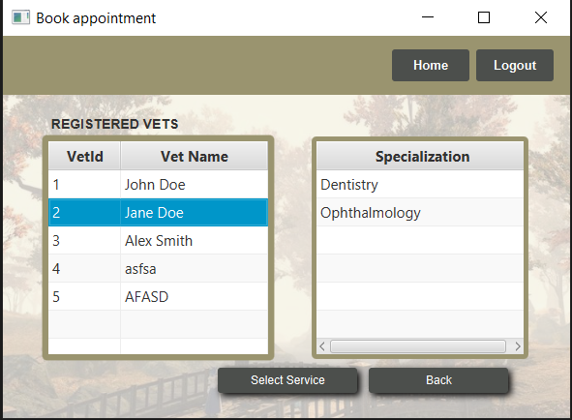

This interface is used to allow the Pet Owners to select a Veterinarian with which they want to book an appointment with. By The Specialization Table, They can see whether the current Veterinarian has the services required by them.

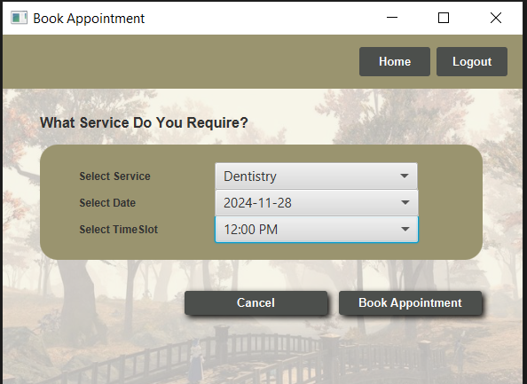

After selecting the Veterinarian with their required services, Pet Owner will enter this interface which will allow them to select the required service from the Veterinarian’s many services. After which, The Pet Owner will select the Date and the time slot of the appointment. The Appointment would be booked and it will go to the Veterinarian for confirmation.

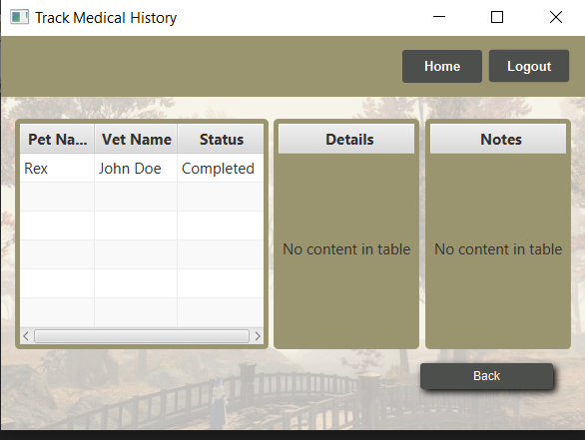

This Interface allows the Pet Owner to see all the Treatment Plans of the Pet. A Treatment Plan can contain many details and notes which will be represented in the tables next to the main table.

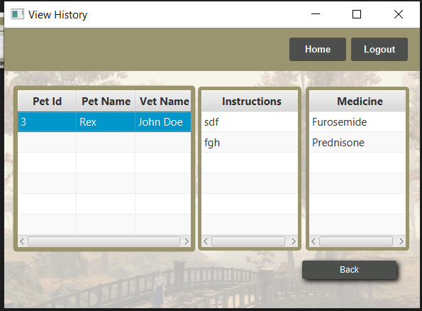This Interface allows the Pet Owner to see all the Prescriptions of the Pet. A Prescription contains many Instructions and Medications which will be represented in the tables next to the main table.



This interface is used to display the medical history of a pet. A medical history contains many records. Meanwhile, A Single record can contain many diagnoses, Symptoms and Treatment Details. This Screen is used to display all of these.

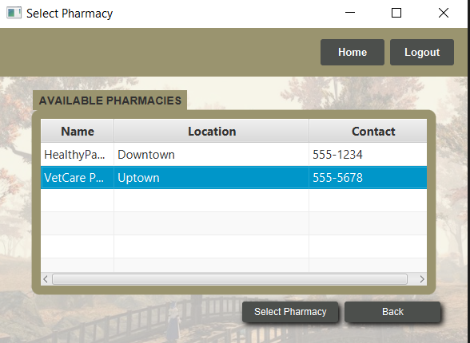

This interface is used to display all the pharmacies registered with the System. This allows the Pet Owner to buy medicines. If one pharmacy does not have the required stock, then the Pet Owner can select another Pharmacy.

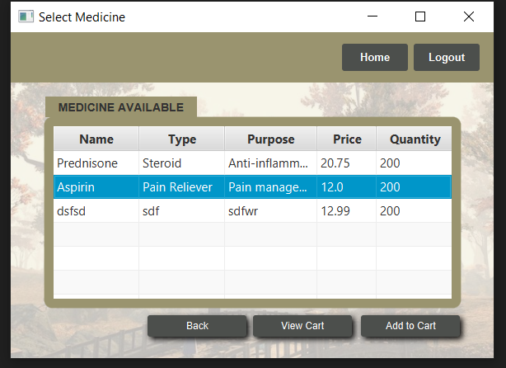

This interface is used to display all medicines of the pharmacy which is selected by the Pet Owner. Here, The Pet Owner can select all the medicines required by him and he can also check whether the Pharmacy has enough stock for his requirement.

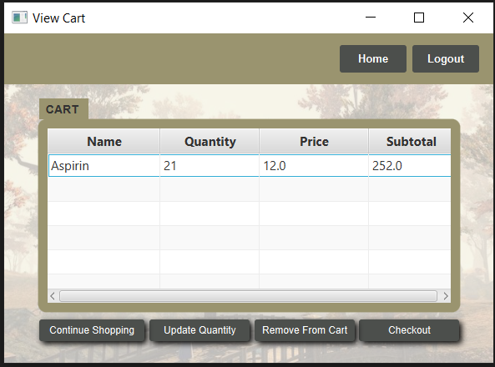

This Interface displays the cart of the Pet Owner. All the medicines selected with the required stocks and price are displayed. Moreover the SubTotal of all these medicines is also displayed.

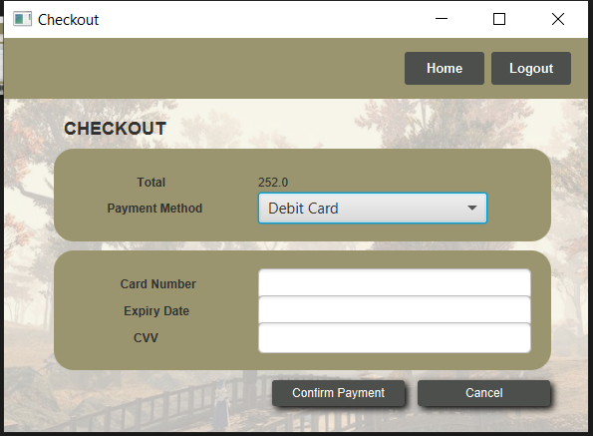

This is the check out of the cart so that the Pet Owner can complete his purchase and there are 2 methods of payment, either by Credit Card or Debit Card.

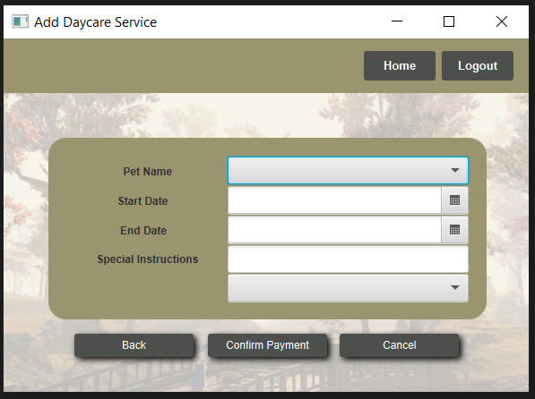

In this Interface, The Pet Owner Books the Daycare service for the Pet. The Owner enters all the details of the service. If the End Date is Selected before the Start Date, An input invalidation error occurs.

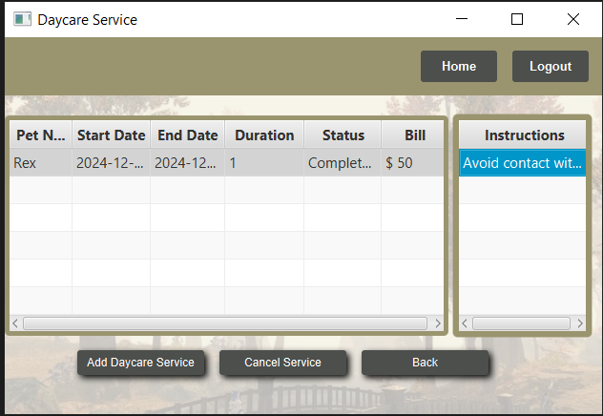

In this Interface, The Pet Owner can view the Daycare Records of his pet and can also go to add new daycare service. He can also cancel the Daycare but the Money will not be refunded. The Instructions has a separate table because A single Daycare can contain many instructions.

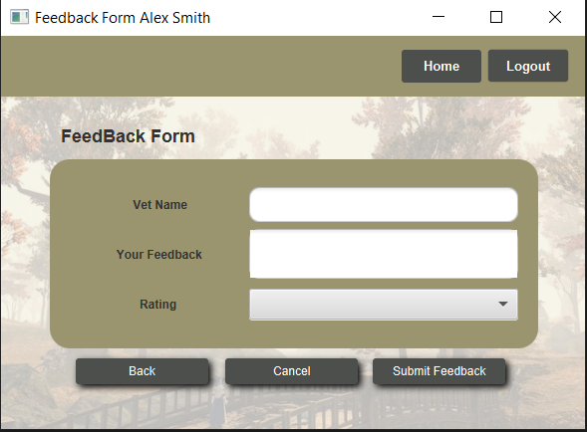

In this Interface, The Pet Owner can give FeedBack to the Veterinarian. He will enter his comment in your Feedback Textbox and select a rating.

**Admin Interfaces:**

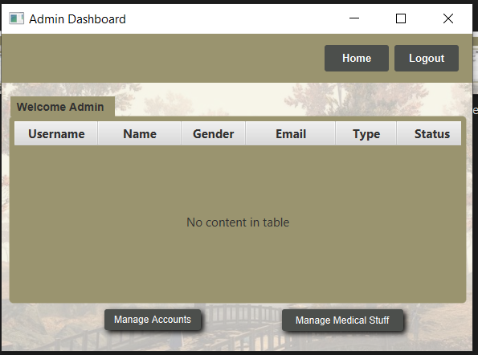

Dashboard for admins that allows them to view details, manage accounts, and lastly manage medical related things like restock pharmacy and add or remove medications.

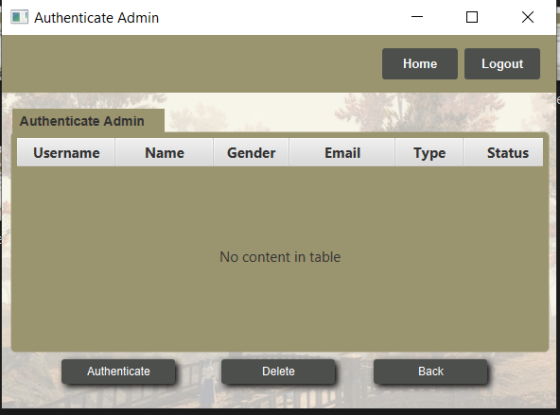

This screen displays a list of newly registered admins awaiting authentication. Existing admins can either authenticate or remove these accounts to ensure the system remains secure.

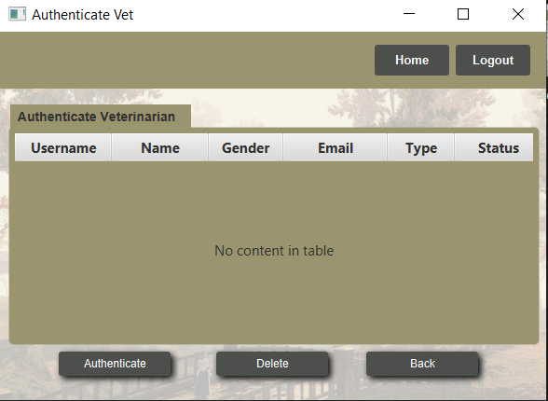

This screen displays a list of newly registered veterinarians awaiting authentication. Existing admins can either authenticate or remove these accounts to ensure the system remains secure.



This interface is used to display all the pharmacies registered with the System. This allows the Admin to select the pharmacy which requires restocking

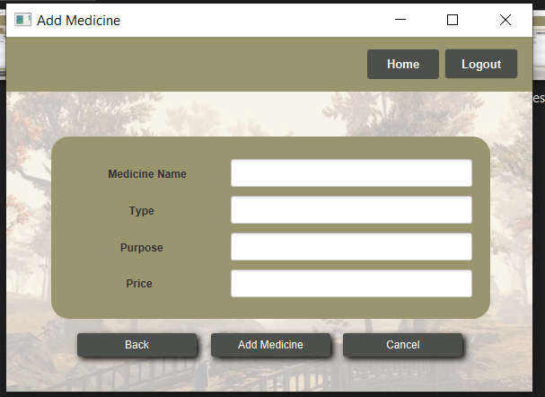

This interface is used to allow the Admin to add New Medicine which can be linked with the registered Pharmacies. If a certain medication is not linked to the system, then the pharmacies are not allowed to show those.

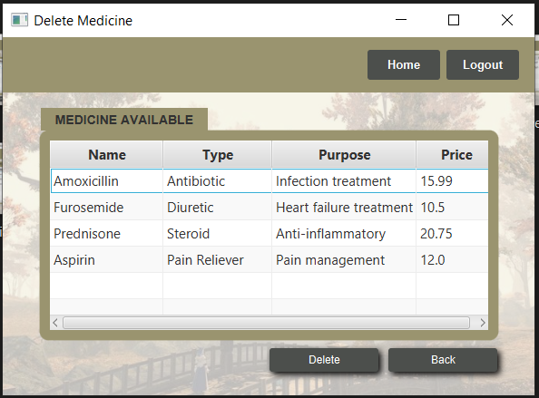

This interface is used to allow the Admin to remove Medicine which are linked with the registered Pharmacies. If a certain medication is linked to the system, and later, it is decided to remove the medicine due to some reason, The Admin will delete the medicine causing a no link b/w system and medicine. This will allow the System to not display it to customers.

Here is a continuation and completion of the Software Requirements Specification (SRS) for the PAWS project based on the provided content:

**Software Requirements Specification for PAWS: A Comprehensive Veterinary Hospital Management System**Page 3

### **1. Introduction**

**1.1 Purpose**This document outlines the software requirements for PAWS, a comprehensive veterinary hospital management system developed for LifeLine Pet Hospital. The system aims to streamline operations such as pet registration, treatment management, billing, and appointment scheduling. PAWS will automate routine administrative tasks and improve the overall quality of animal care by providing an efficient, user-friendly platform for veterinarians, staff, and pet owners.

**1.2 Product Scope**PAWS is a centralized system designed to enhance veterinary hospital operations by automating key processes, reducing manual workloads, and improving patient care. The system will store electronic medical records, handle appointment scheduling, facilitate inventory management, and enable secure billing and payment. Additionally, PAWS integrates features for managing staff roles, appointment reminders, and reporting. This system will be tailored to LifeLine Pet Hospital but will also be adaptable for other veterinary clinics.

**1.3 Title**PAWS: Veterinary Hospital Management System

**1.4 Objectives**

* Develop an integrated system to manage veterinary hospital operations.
* Improve animal patient care by providing efficient data management.
* Enhance administrative efficiency, reducing operational costs.
* Ensure data security and compliance with veterinary regulations.
* Provide real-time updates on patient treatment and billing.

**1.5 Problem Statement**Veterinary hospitals face challenges related to inefficient management of animal care, staff, and resources. Many clinics rely on outdated systems that create bottlenecks in routine tasks such as appointment scheduling, patient record management, and inventory tracking. These inefficiencies lead to delays in treatment, frustrated pet owners, and ultimately lower-quality care. PAWS addresses these issues by automating processes and providing a unified digital platform for seamless communication and efficient operation.

### **2. Overall Description**

**2.1 Product Perspective**PAWS is a standalone solution designed to automate and optimize operations at LifeLine Pet Hospital. The system will replace manual processes and outdated software, providing a more effective solution for managing patient care and clinic resources. PAWS will interact with existing hardware, including medical devices, pharmacy management systems, and payment processing tools.

**2.2 Product Functions**

* **Pet Registration:** Streamline the registration of new pets, saving medical records electronically.
* **Medical Record Management:** Create and update patient records with treatment history, vaccination details, and other relevant data.
* **Appointment Scheduling:** Allow pet owners to schedule appointments with veterinarians and receive reminders.
* **Billing:** Process payments and generate invoices for treatments and medications.
* **Inventory Management:** Track medications, supplies, and equipment usage.
* **Reporting:** Generate reports on patient care, inventory, and clinic operations.

**2.3 List of Use Cases**

* **Pet Owner Registration:** A pet owner registers their pet with the clinic.
* **Schedule Appointment:** A pet owner schedules an appointment with a veterinarian.
* **Record Treatment:** A veterinarian records treatment details for a pet.
* **Bill for Services:** The system generates an invoice for the pet owner after a visit.
* **Manage Inventory:** The staff updates inventory levels and tracks medication usage.

**2.4 Extended Use Cases**

* **Emergency Appointment Scheduling:** In case of an emergency, pet owners can book urgent appointments.
* **Medication Purchase:** Pet owners can purchase prescribed medicines directly from the clinic’s pharmacy.

**2.5 Use Case Diagram**A diagram illustrating the interactions between users (pet owners, veterinarians, clinic staff) and the system will be provided here.

### **3. Other Nonfunctional Requirements**

**3.1 Performance Requirements**

* The system should handle up to 500 concurrent users without performance degradation.
* Data processing should be completed within 3 seconds for patient registration and billing operations.
* Real-time updates should be reflected in the system immediately after an action (e.g., appointment booking, treatment recording).

**3.2 Safety Requirements**

* The system should protect sensitive patient data by implementing encryption and access control measures.
* Backup processes should ensure data recovery in case of hardware failure.

**3.3 Security Requirements**

* User authentication is required for all users (pet owners, veterinarians, staff).
* Access control mechanisms must ensure that only authorized personnel can access and modify patient records.
* The system must comply with relevant data protection regulations (e.g., GDPR, HIPAA).

**3.4 Software Quality Attributes**

* **Reliability:** The system must be available 99.9% of the time.
* **Usability:** The system should be intuitive and easy to navigate for all users.
* **Maintainability:** The system should be easily maintainable with well-documented code and modular design.
* **Scalability:** The system should be capable of supporting future expansions (e.g., additional hospitals or new features).

**3.5 Business Rules**

* Only registered pet owners can schedule appointments for their pets.
* Veterinarians can access and update medical records for pets under their care.
* Inventory updates must be logged by authorized staff.

**3.6 Operating Environment**

* The system will operate on Windows and Linux-based servers.
* It will be accessible via web browsers (Chrome, Firefox, Edge) and mobile devices.
* A cloud-based infrastructure will be used to ensure scalability and reliability.

**3.7 User Interfaces**The system will feature a user-friendly interface for both veterinarians and pet owners. Key components include:

* **Pet Owner Portal:** Interface for pet registration, appointment scheduling, and billing.
* **Veterinarian Portal:** Interface for managing medical records, scheduling, and reporting.
* **Admin Portal:** Interface for clinic staff to manage inventory, view reports, and handle billing.

### **4. Domain Model**

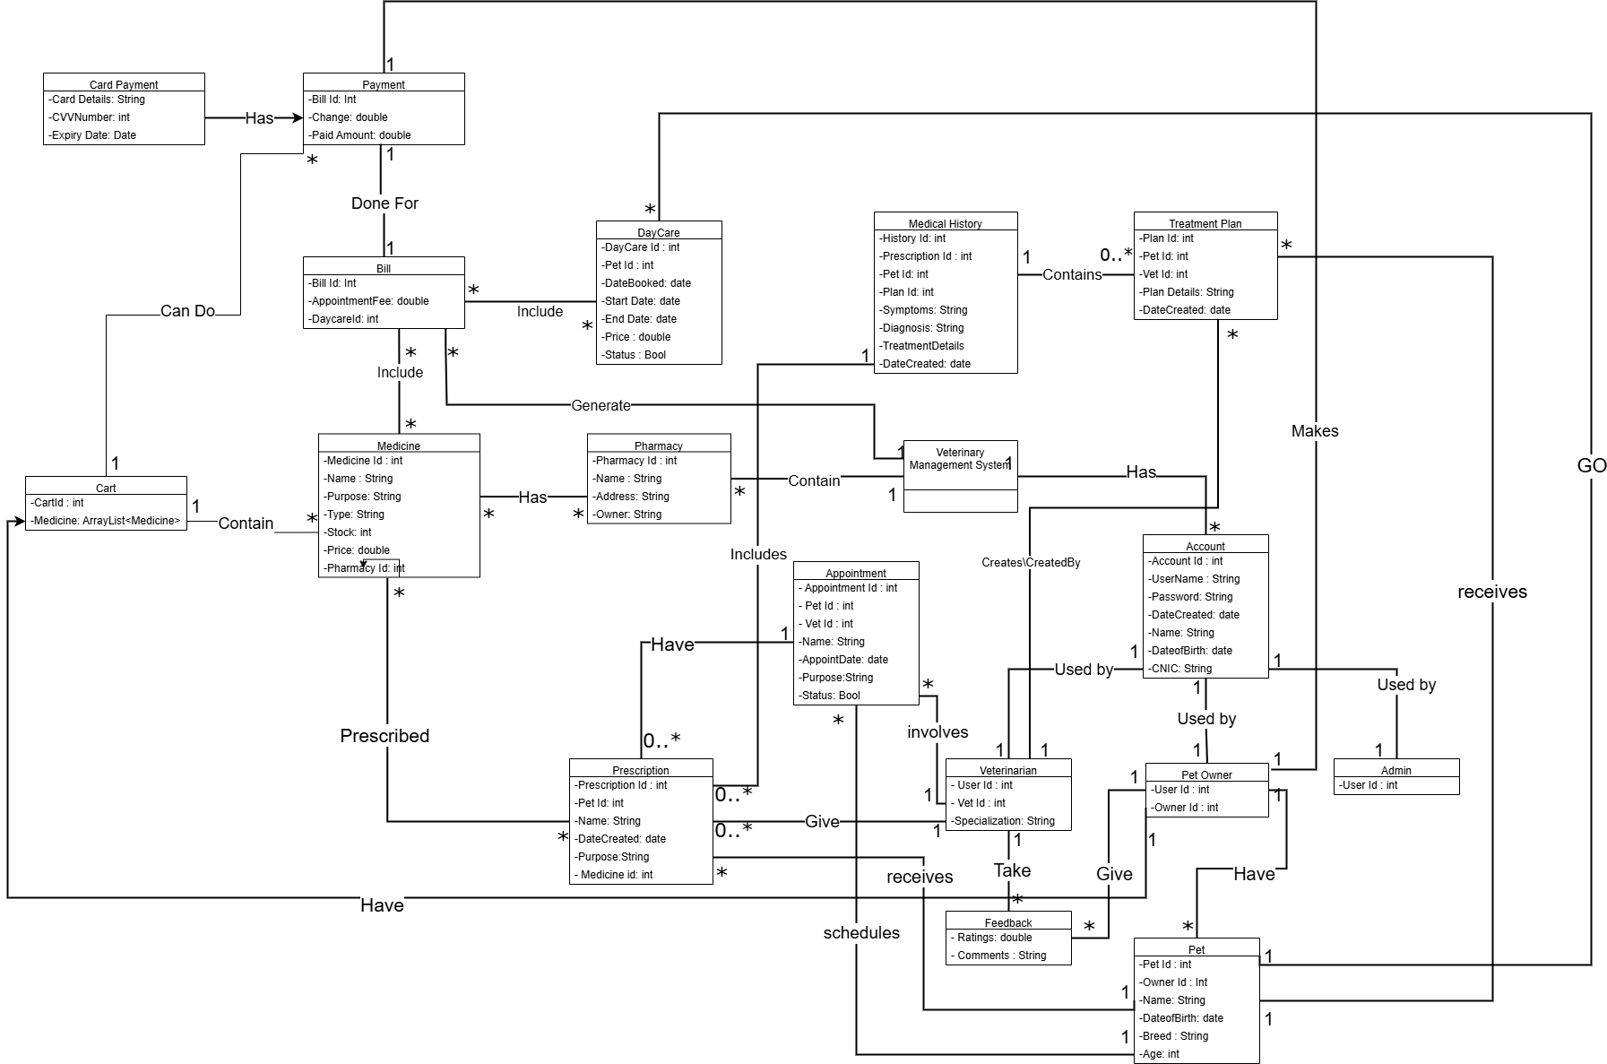

**5.SYSTEM SEQUENCE DIAGRAMS:**

**Pet Owner:**

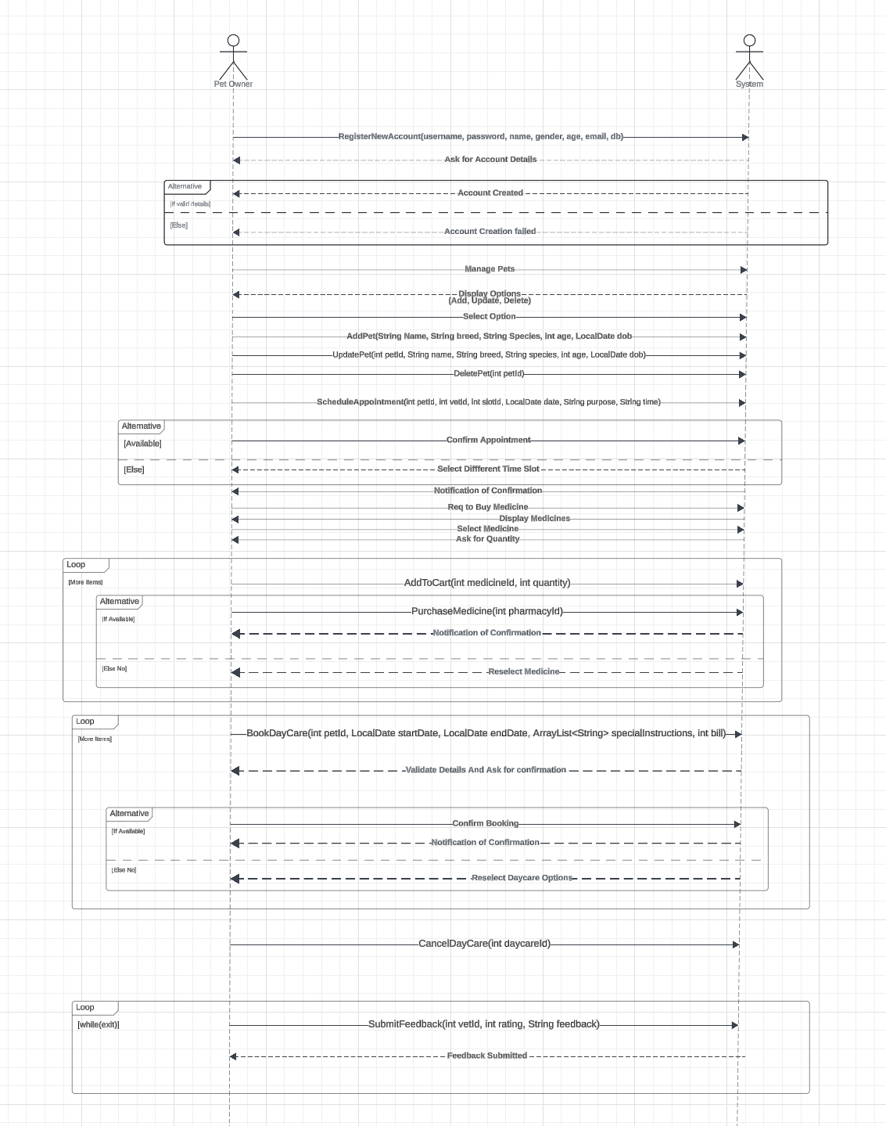

**Vet:**

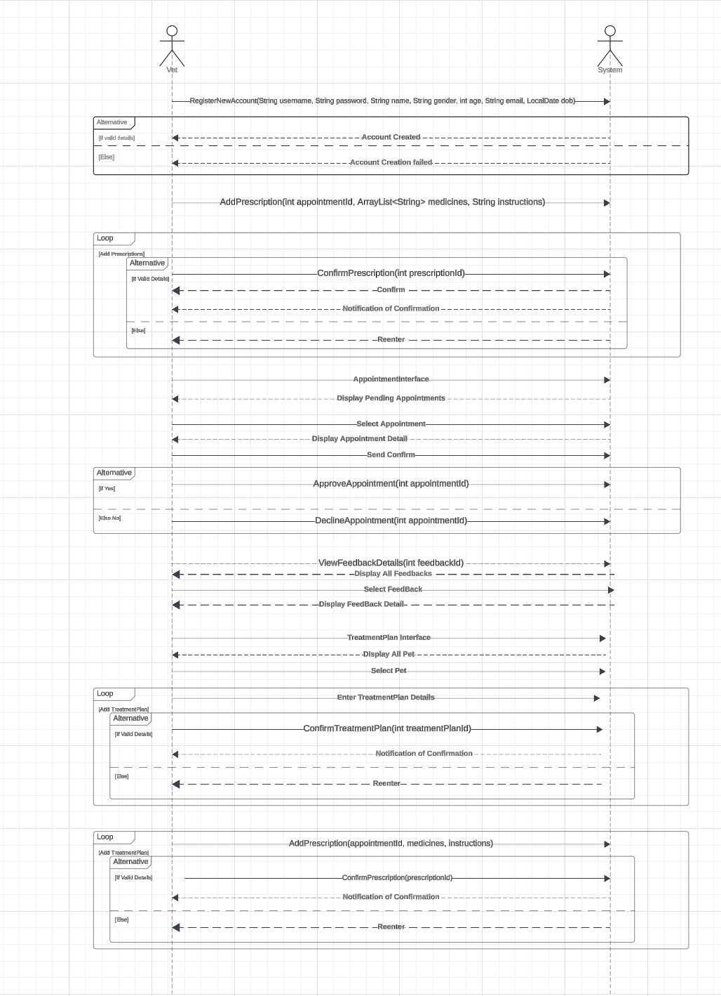

**Admin:**

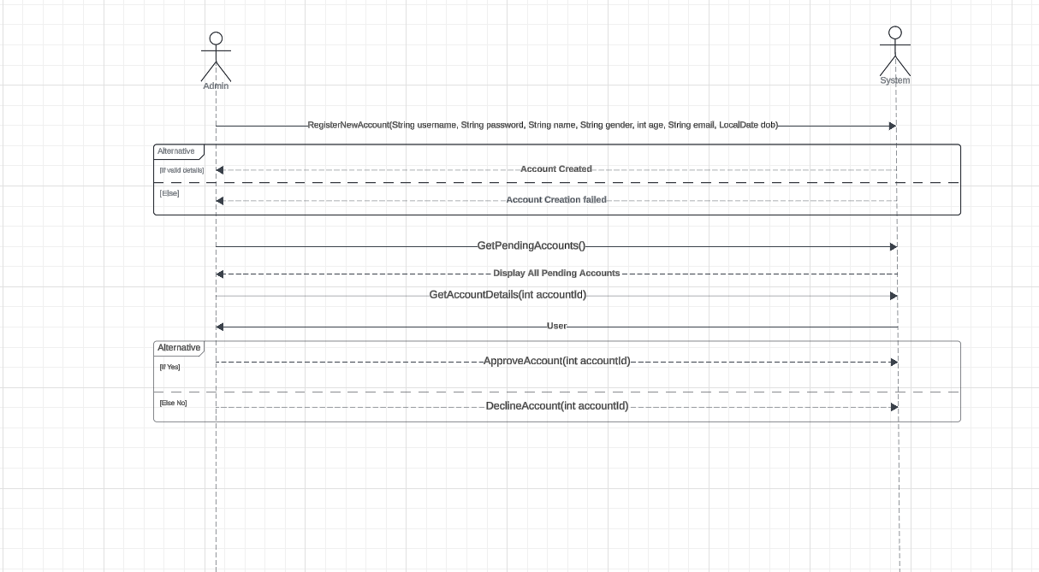

**6.Action Sequence Diagram**

**Manage Account 1:  
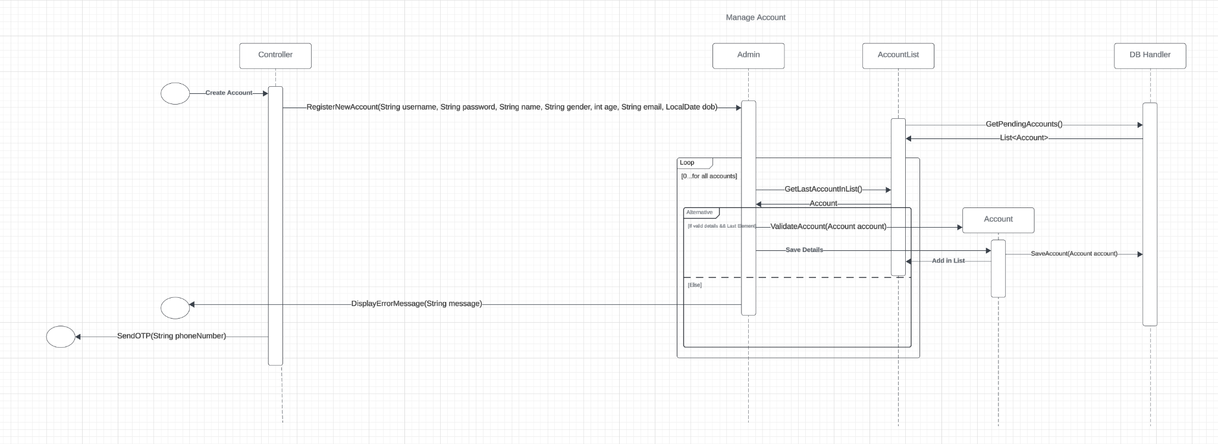**

**Manage Account 2:**

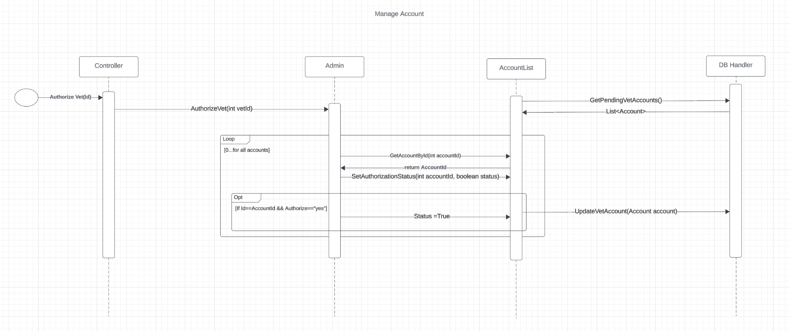

**Manage Pet (ADD):  
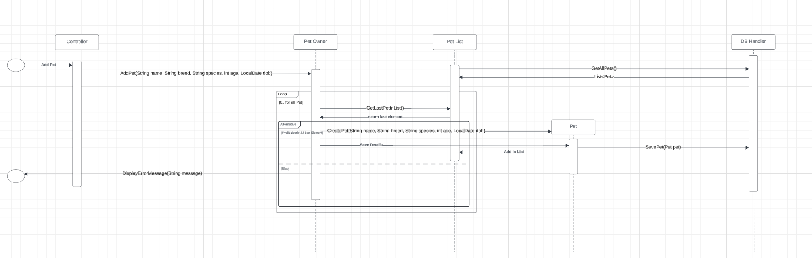  
Manage Pet (Display):  
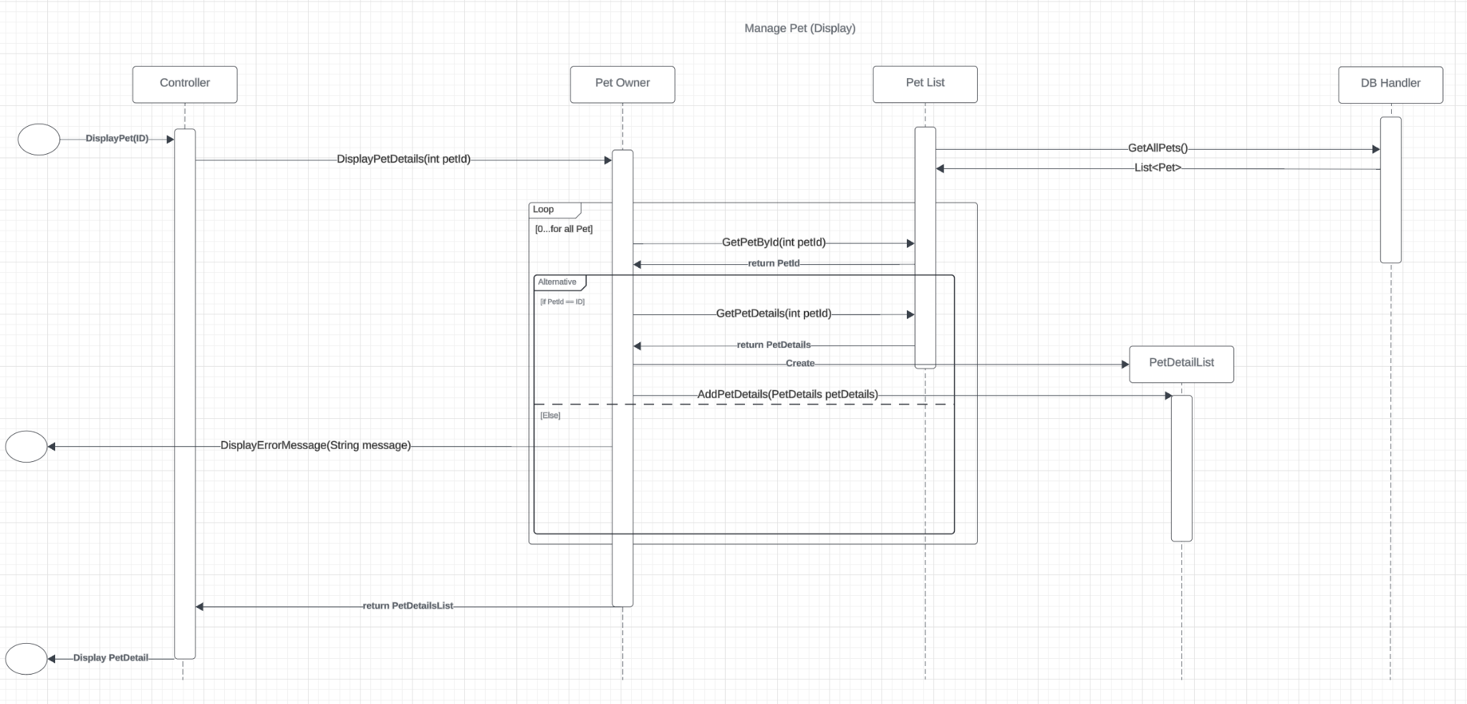  
Manage Pet (Delete):**

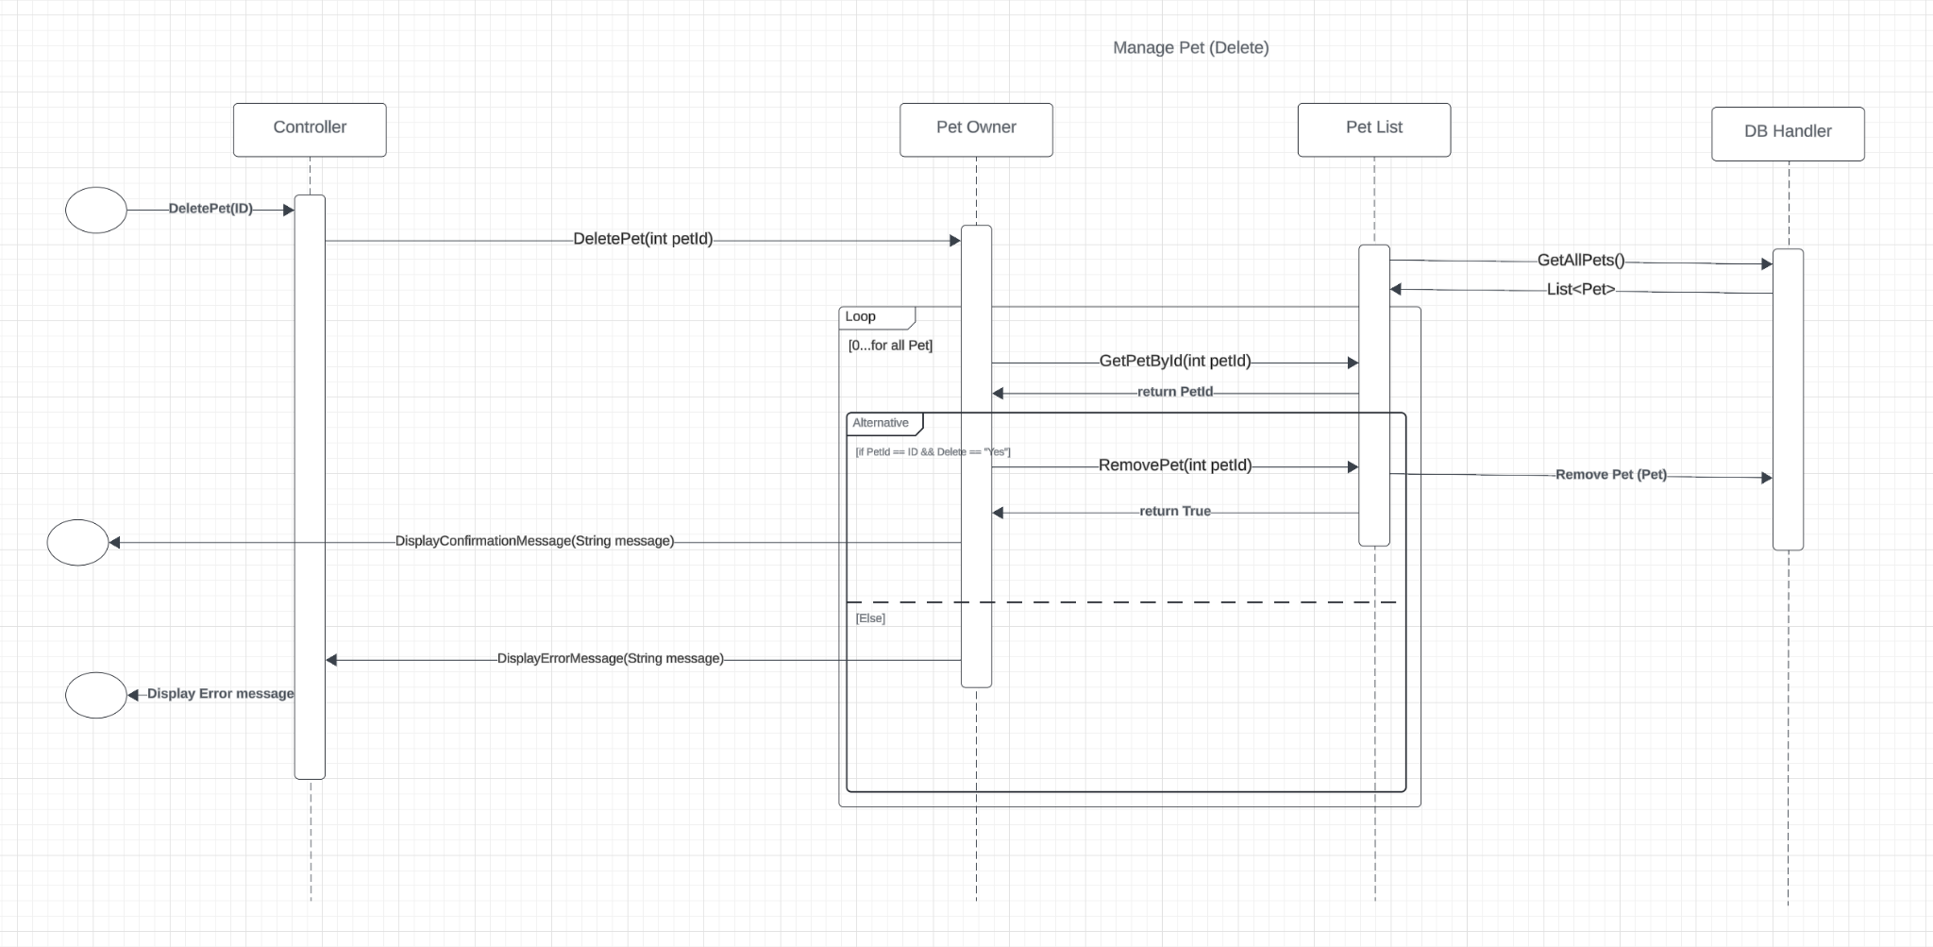

**Record Prescription:  
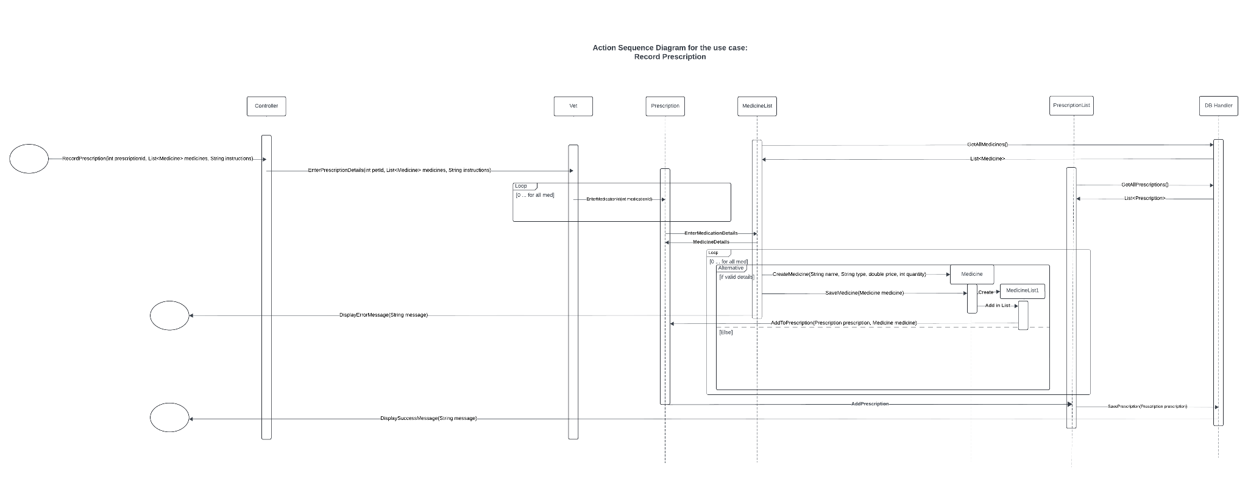**

**Schedule Appointment:  
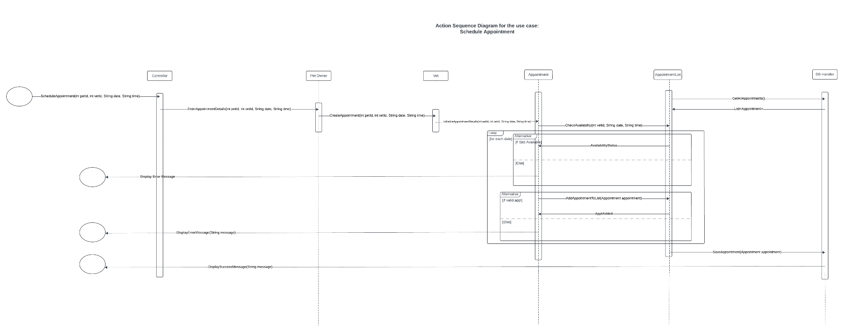**

**Track Medical History:**

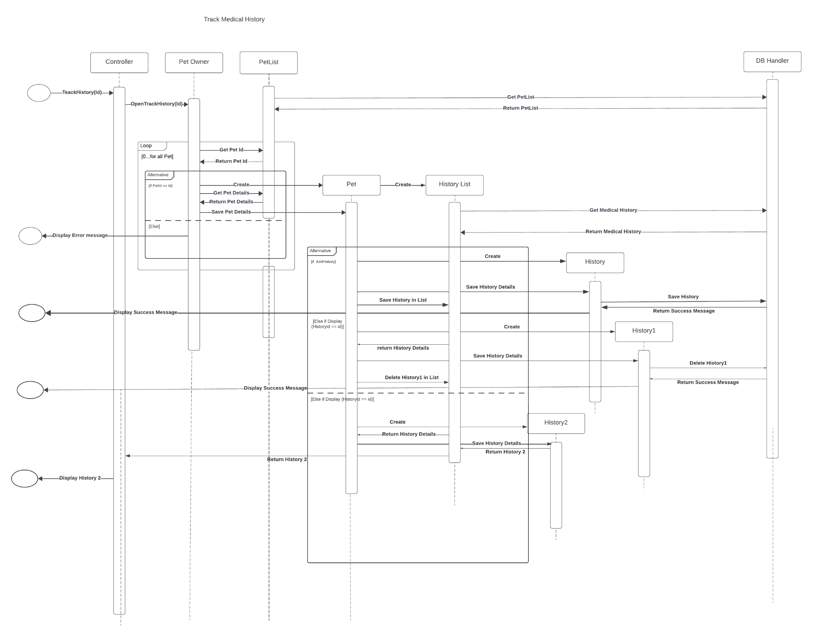

**Treatment Plan**

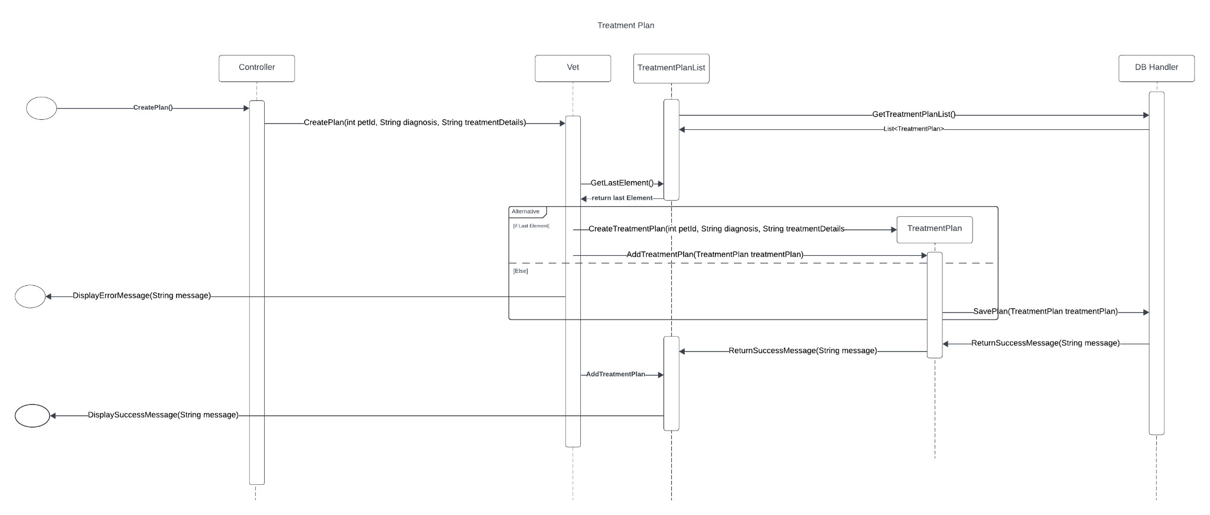

**Component:**

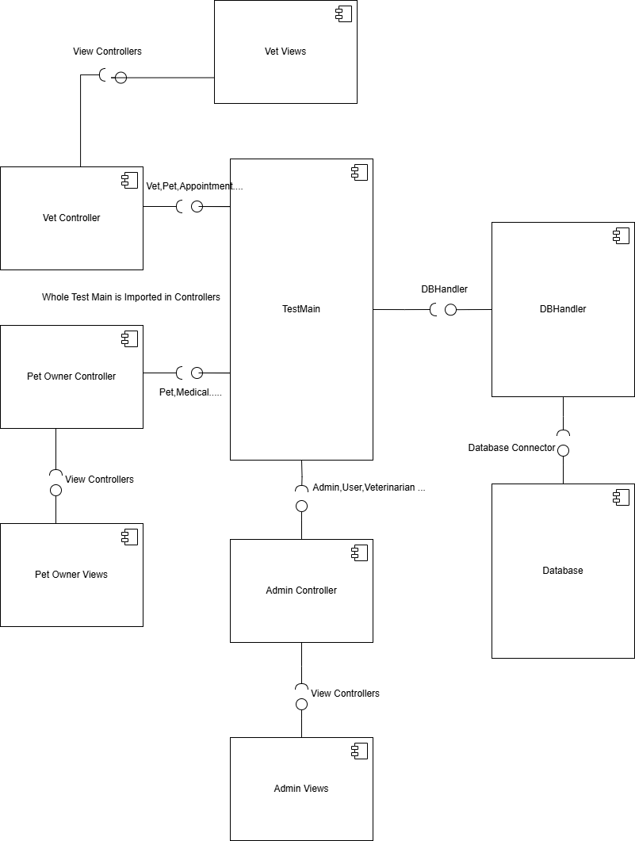

**Package:**

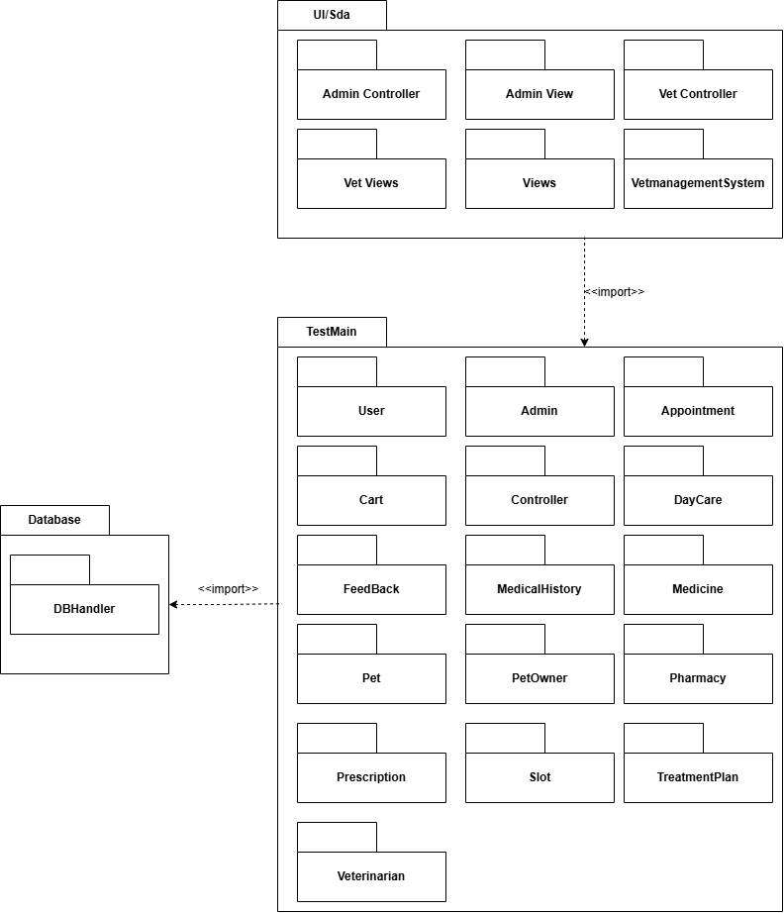

**Deployment Diagram:**

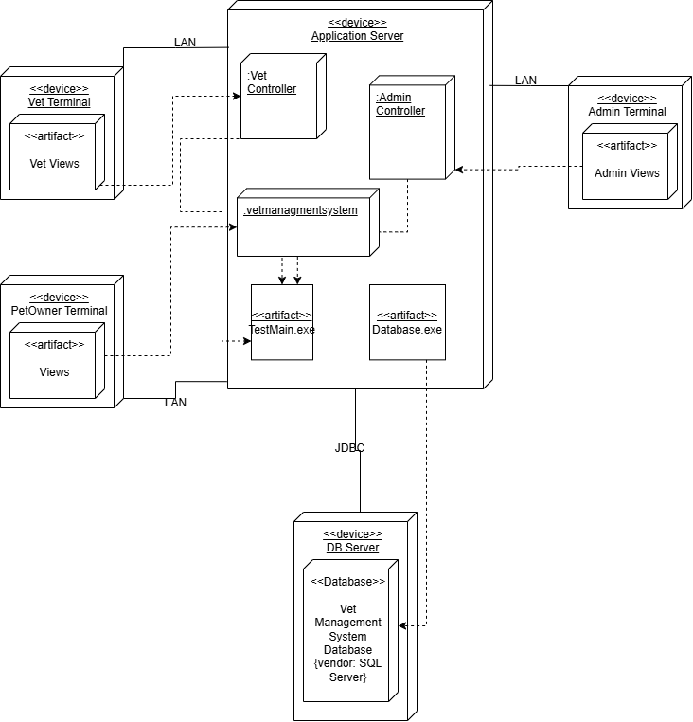

**Class Diagram:  
